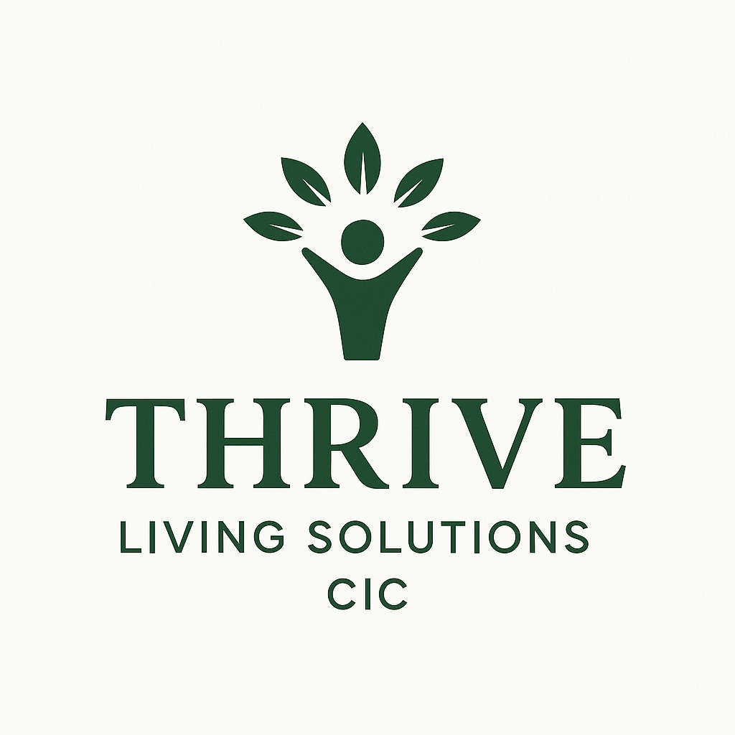

Unfortunately, Thrive Living Solutions CIC Cannot Accept referrals for any type of Sexual Offense, spent or unspent convictions or Sexual behaviors. We cannot accept any Arson Offenses or High-Risk Violent Offenses for the same reasons.

Date accommodation required: |  |  | Referral date:
Client full name: |  |  | Client contact number:
Client current address:

Client DOB: |  |  | Client NI number:
Referrer’s name: |  |  | Referrer’s company:
Referrer’s contact number: |  |  | Referrer’s contact email address:
Area desired: | North East |  | East Midlands |  | London
 | North West |  | West Midlands |  | South East
 | Yorkshire and the Humber |  | East of England |  | South West

What Area does the Client have A Local Connection?.............................................

Risk assessment

Identified risk |  | Please circle level of risk
Risk to children | YES/NO | LOW | MEDIUM | HIGH
Risk to self | YES/NO | LOW | MEDIUM | HIGH
Risk to other clients | YES/NO | LOW | MEDIUM | HIGH
Risk to staff | YES/NO | LOW | MEDIUM | HIGH
Risk to females | YES/NO | LOW | MEDIUM | HIGH
Arson | YES/NO | LOW | MEDIUM | HIGH
Please provide information on any identified risk
Other information
Current Medication
Substance misuse background
Substance of Choice,
Is the Client Still Actively using?
Previous criminal convictions.
(Probation Officers Name, if known.)
Has the client been in supported housing before?
How long have you known the client and in what capacity?
Ability of client to work with people (including staff)
Ability of client to think and reflect
Client’s adaptability to new experiences
Client’s communication skills
Client’s ability to deal with own emotions
Client’s Motivation

Client’s budgeting skills/ ability to manage a tenancy
Any previous recovery-based interventions undertaken by client, are they willing to engage with Drug services?
CGL worker details.
Would the client be able to sustain a tenancy without the delivery of housing related support and intensive housing management

Thank you for taking the time to complete the referral. Please email the referral form to info@thrivelivingcic.co.uk/and a member of staff will be inContact within 24/48 hours.

Signature of referrer

Print name

Date

Signature of client

Print name

Date

Client is not present to sign but is aware that a referral is being made on their behalf, (please print, sign and date underneath)

Print name______________________________________________________

Signature _______________________________________________________

Date____________________________________________________________
Any further information/ Comments.

